Penetration Test Report
For
All Ports Tours

Team XX
Region: Western
{date | convertDateLocale: ‘us’: ‘full’}

{%company.logo}

Confidentiality Notice
This report contains sensitive, privileged, and confidential information. Precautions should be taken to protect the confidentiality of the information in this document. Publication of this report may cause reputational damage to All Ports Tours or facilitate attacks against All Ports Tours. Team XX shall not be held liable for special incidental, collateral or consequential damages arising out of the use of the information.
Disclaimer
Note that this assessment may not disclose all vulnerabilities that are present on the systems within the scope of the engagement. This report is a summary of the findings from a “point-in-time” assessment mode on All Ports Tour’s environment. Any changes made to the environment during the period of testing may affect the results of the assessment.
Report Legend:
report_legend_here – Confidential / PII
report_legend_here – Internal Use Only
OR?
[CONFIDENTIAL] Name: John Doe
[INTERNAL USE ONLY] Name: John Doe

Password Protect documents (microsoft word?)
Table of Contents
Executive Summary 4
High Level Assessment Overview 5
Background 5
Observed Strengths 5
Areas for Improvement 5
Business Impact 5
Recommendations 5
Scope 6
Networks Covered 6
Testing Methodology 7
Actions Completed by Team XX 7
Classification Definitions 8
Risk Level 8
Exploitation Likelihood 8
Business Impact 9
Remediation Difficulty 9
Vulnerabilities Summary 10
Technical Details 13
Recommendations 17
Summary 17
Migration to Microsoft Entra and Hybrid Identity Planning 17
Ransomware as a Major Threat and the Value of External Validation 17
Conclusion 19
Appendix A: Evidence Manifest 20
Appendix B: Network Diagram 21
Appendix C: Communication Log 22

Executive Summary
Purpose: Summarize the engagement for a non-technical executive.
- Scope: Describe what systems, applications, or networks were in scope.
- Objective: State what you were tasked to assess (e.g., external perimeter, internal, web apps).
- Approach Overview: “Team XX simulated an authorized penetration test… using industry-standard tools and methodologies.”
Critical | High | Medium | Low | Total
{findings | count: ‘Critical’} | {findings | count: ‘High’} | {findings | count: ‘Medium’} | {findings | count: ‘Low’} | {findings | length}
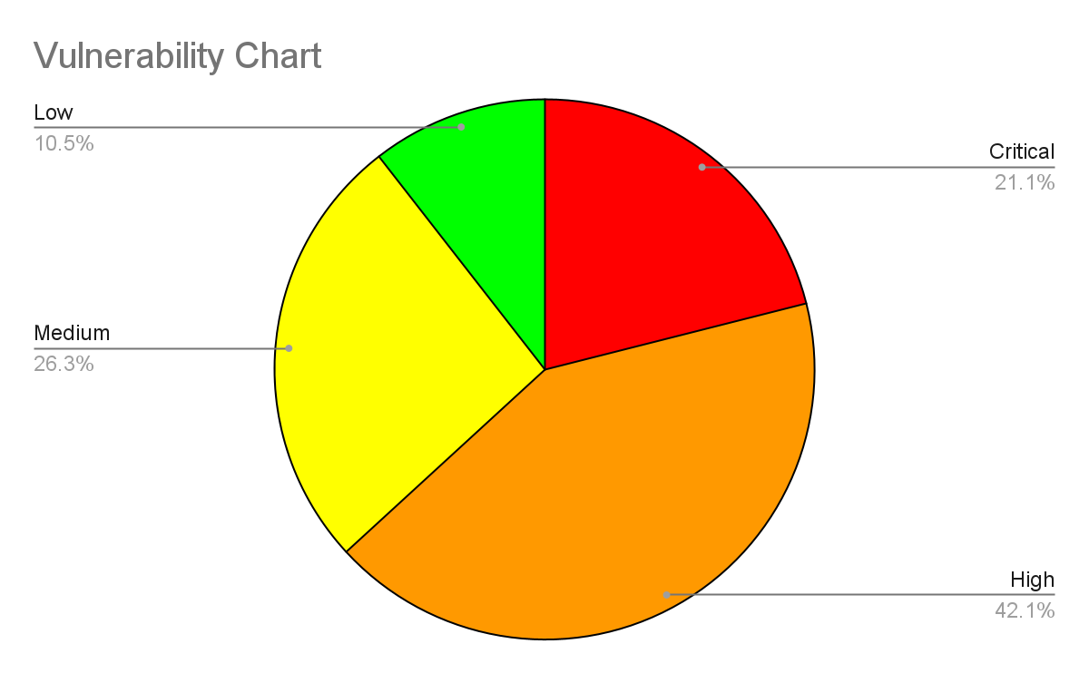
-Key Takeaways:
- Critical vulnerabilities found (list 3–5 highlights).
- Business impact (e.g., “Potential compromise of payroll records through weak credential reuse”).
- Recommended immediate actions.

High Level Assessment Overview

Background
placeholder text

Observed Strengths
placeholder text

Areas for Improvement
placeholder text

Business Impact
placeholder text

Recommendations
short term / long term overall / high priority recommendations

Scope
Asset inventory / attack surface list — IPs, hostnames, services, public URLs, exposed ports.

Networks Covered
● {-w:p scope}{name}{/scope}

Testing Methodology

Actions Completed by Team XX
Test timeline / engagement log — dates & times of tests, windows used, and who ran each test.

Classification Definitions

Risk Level
Severity | CVSS Score | Description
Critical | 9.0 - 10.0 | The vulnerability is critical and poses an immediate threat. These vulnerabilities may compromise the entire system and should be remediated immediately.
High | 7.0 - 8.9 | The vulnerability poses a severe threat to the system and should be prioritized for remediation.
Medium | 4.0 - 6.9 | The vulnerability poses a moderate threat to the system and should be remediated as soon as possible, after higher priority issues are resolved.
Low | 0.1 - 3.9 | The vulnerability poses minimal threat to the system and should be remediated if possible during routine maintenance.
None | 0 | The vulnerability does not pose a direct threat to the system but should be monitored by the company as they may provide information that would assist in an attack.

Exploitation Likelihood
Likelihood Level | Description
Almost Certain | Exploitation of this vulnerability is almost certain. There are significant security vulnerabilities and methods of exploitation are publicly available and can be easily performed.
Likely | Exploitation of this vulnerability is likely. The vulnerabilities are present and the methods of exploitation can be performed by attackers with moderate skill.
Possible | Exploitation of this vulnerability is possible but there are significant barriers in place that reduce the chance of exploitation. The vulnerabilities and methods of exploitation may be less known publicly.
Unlikely | Exploitation of this vulnerability is unlikely.The vulnerabilities are difficult to exploit and would require an experienced attacker with a deep understanding of the system in place.

Business Impact
Impact Level | Description
Major | Exploitation of this vulnerability would cause a severe or catastrophic disruption to the business’s operations or exposure of sensitive assets and/or confidential information.
Moderate | Exploitation of this vulnerability would moderately disrupt the business’s operations, with temporary but manageable defects if they are remediated appropriately.
Minor | Exploitation of this vulnerability would have minimal impact on business operations. This vulnerability would not disrupt daily routines, and most likely only affect a few users.

Remediation Difficulty
Difficulty Level | Description
Complex | Fixing this issue may require major system reconfiguration and significant time investment. It could also disrupt normal business operations.
Medium | Fixing this issue may involve minor system changes or additionals that take some time or incur moderate cost.
Easy | Fixing this issue can be done quickly with minimal effort or impact.

Vulnerabilities Summary
ID | Vulnerability | CVSS Score | Likelihood | Business Impact | Remediation Difficulty | Risk
{#findings}{#cvss.baseSeverity == 'Critical'}{identifier | changeID: ''} | {title} | {@cvss.cellColor}  {cvss.baseMetricScore} | {likelihood} | {impact} | {#remediationComplexity == '0'}Easy{/remediationComplexity == '0'}  {#remediationComplexity == '1'}Medium{/remediationComplexity == '1'}  {#remediationComplexity == '2'}Complex{/remediationComplexity == '2'} | {cvss.baseSeverity}{/cvss.baseSeverity == 'Critical'}{/findings}
{#findings}{#cvss.baseSeverity == 'High'}{identifier | changeID: ''} | {title} | {@cvss.cellColor}  {cvss.baseMetricScore} | {likelihood} | {impact} | {#remediationComplexity == '0'}Easy{/remediationComplexity == '0'}  {#remediationComplexity == '1'}Medium{/remediationComplexity == '1'}  {#remediationComplexity == '2'}Complex{/remediationComplexity == '2'} | {cvss.baseSeverity}{/cvss.baseSeverity == 'High'}{/findings}
{#findings}{#cvss.baseSeverity == 'Medium'}{identifier | changeID: ''} | {title} | {@cvss.cellColor}  {cvss.baseMetricScore} | {likelihood} | {impact} | {#remediationComplexity == '0'}Easy{/remediationComplexity == '0'}  {#remediationComplexity == '1'}Medium{/remediationComplexity == '1'}  {#remediationComplexity == '2'}Complex{/remediationComplexity == '2'} | {cvss.baseSeverity}{/cvss.baseSeverity == 'Medium'}{/findings}
{#findings}{#cvss.baseSeverity == 'Low'}{identifier | changeID: ''} | {title} | {@cvss.cellColor}  {cvss.baseMetricScore} | {likelihood} | {impact} | {remediationComplexity}{#remediationComplexity == '0'}Easy{/remediationComplexity == '0'}  {#remediationComplexity == '1'}Medium{/remediationComplexity == '1'}  {#remediationComplexity == '2'}Complex{/remediationComplexity == '2'} | {cvss.baseSeverity}{/cvss.baseSeverity == 'Low'}{/findings}

Technical Details
{#findings}

{identifier | changeID: ''} {title}
CVSS Severity | {@cvss.cellColor}  {cvss.baseSeverity} | CVSS Score | {@cvss.cellColor}  {cvss.baseMetricScore}
Type | {vulnType} | Category | {category}
Attack Vector | {cvss.vectorString}
Business Impact | {impact}
Exploitation Likelihood | {likelihood}
Remediation Difficulty | {#remediationComplexity == '0'}Easy{/remediationComplexity == '0'}  {#remediationComplexity == '1'}Medium{/remediationComplexity == '1'}  {#remediationComplexity == '2'}Complex{/remediationComplexity == '2'}

Description
{#description}
{@text | convertHTML}
{#images}
{%image}
Image 1 – {caption}
{/images}
{/description}

Observation
{#observation}
{@text | convertHTML}
{#images}
{%image}
Image 1 – {caption}
{/images}
{/observation}

Impact
placeholder text

Evidence
{#poc}
{@text | convertHTML}
{#images}
{%image}
Image 1 – {caption}
{/images}
{/poc}

Reproduction
placeholder text

Recommendations
{#remediation}
{@text | convertHTML}
{#images}
{%image}
Image 1 – {caption}
{/images}
{/remediation}

References
{#references}
{.}
{/references}

{/findings}

Recommendations

Summary
- Enforce strong credential and password rotation policies.
- Patch outdated OS and web software.
- Implement centralized logging and monitoring.
- Segment internal networks.
- Deploy MFA for administrative accounts.

Migration to Microsoft Entra and Hybrid Identity Planning
The client is currently planning a migration from Microsoft Entra ID (Entra) — moving away from traditional Active Directory (AD) — and may adopt a hybrid identity model (on-premises + cloud). This transition represents a strategic move towards a more scalable, flexible identity and access management (IAM) structure. According to Microsoft documentation, hybrid identity “creates a common user identity for authentication and authorization to all resources, regardless of location.” Microsoft Learn+1
By moving to Entra, the organization can strengthen its security posture through advanced capabilities such as Conditional Access, MFA, and consolidated identity governance. A recent commissioned study by Forrester Research found that organisations adopting the Entra Suite achieved a 240 % ROI and significantly reduced identity-related risks and vendor sprawl. Microsoft+1
When adopting a hybrid model, the client retains on-premises infrastructure where needed (e.g., legacy apps) while leveraging Entra’s cloud-native identity services for newer applications and remote access scenarios. For this migration to be successful, it’s recommended that the team assesses existing identity footprints (users, groups, privileges, dependencies), plans synchronization strategies (e.g., Azure AD Connect), and enables security-centric features such as Entra Identity Protection and Privileged Identity Management (PIM). These steps help mitigate credential-based risks and over-privileged access. Kocho
Modern identity platforms also tie directly into threat-monitoring and detection capabilities. For example, Entra’s integration with broader Defender tools enables real-time visibility across cloud and on-premises identity systems. Microsoft

Ransomware as a Major Threat and the Value of External Validation
Ransomware continues to impose one of the most pervasive threats in today’s cybersecurity landscape. According to the Sophos “State of Ransomware 2025” report, the average cost to recover from a ransomware incident (excluding any ransom paid) reached approximately US $1.53 million globally. Bright Defense+1
In a separate global study by CrowdStrike, 78 % of respondent organisations reported being hit by ransomware in the past year, yet only 22 % of victims who believed they were “very well prepared” managed to recover within 24 hours. CrowdStrike
In terms of identity and access risk, a 2024 report by SpyCloud found that 91 % of organisations reported an identity-related breach in the past year—highlighting how identity remains a major attack vector. SpyCloud
Given these trends, external validation of security controls (penetration testing, red-team exercises, third-party audits) becomes critical to maintain resilience. External validation helps confirm that identity controls, detection capabilities, and recovery processes are working as intended—not just configured. This aligns with best practices for defending against highly targeted ransomware campaigns that exploit identity weaknesses, lateral movement opportunities, and mis-configured access.
By pairing the migration to Entra with external validation, the organisation can:
- Ensure the new hybrid identity architecture is configured securely and supports modern threat-detection.
- Confirm that identity-based access controls (MFA, least-privilege, conditional access) are enforced and effective.
- Validate recovery and incident-response capabilities in the event of a ransomware or identity-compromise incident.

Conclusion
Team XX identified multiple high-risk vulnerabilities that could lead to full system compromise. The recommended mitigations are actionable and, if implemented, will significantly improve the organization’s security posture.
Sign-off
Team Captain: ____________________
Report Compiled By: ____________________
Date: ____________________

Appendix A: Evidence Manifest
placeholder text

Appendix B: Network Diagram
(Insert diagram showing internal network, jump box, pfSense, and host relationships.)

Appendix C: Communication Log
Chronological list of injects, questions, and submissions.

